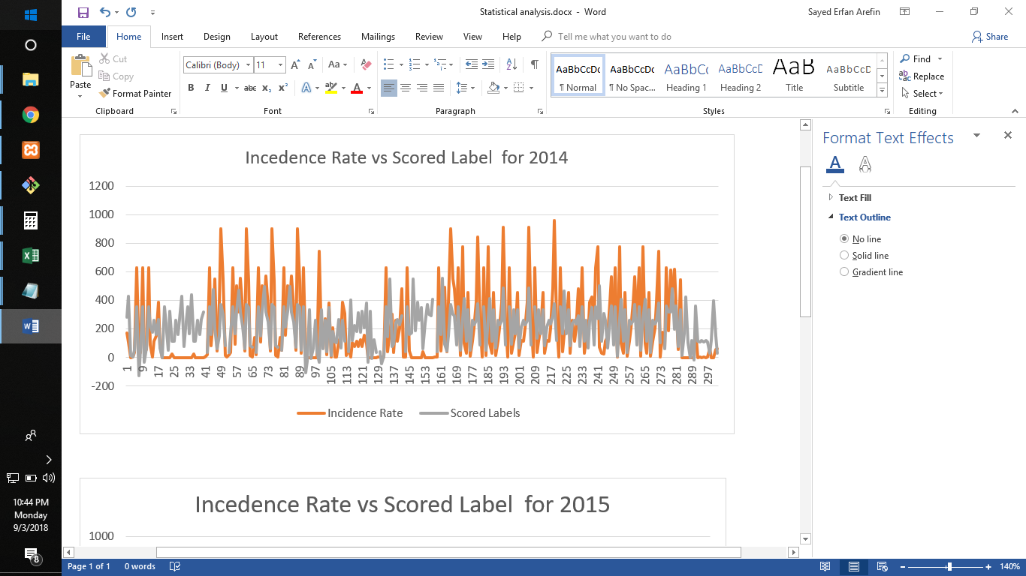

|  |  |
| --- | --- |
| **Mean Absolute Error** | **0.431976** |
| **Relative Squared Error** | **0.422802** |
| **Coefficient of Determination** | **0.577198** |